Integrate front-end and backend
Using the previous server exercises you worked on and the resources provided this week, including the launch.json to help with debugging, create the following
- A Node express server with the following routes:
GET /products/items
This returns an array of unique items from the provided data file. E.g., Laptop, Scanner etc

GET /products/:item
Return all products of the requested item type including all data fields for the items

POST /products/purchase
Post an array of selected item IDs in JSON format. Use these to look up the item costs, sum them then return the total cost

- Test your endpoints using LiteClient or similar

- Create html, css and javascript to enable the user to select either all items or a subset by type
The dropdown items should load dynamically such that if a new item type, e.g. microwave is added or an item type such as all scanners goes out of stock, then your code should not need to be modified to account for the change in data.

Your html, css ad javascript should be served from an express static web server express.static

Display the items with a checkbox in a table
Enable the user to select items using the checkboxes
Submit the item IDs then display the returned total cost with an appropriate message
For example:

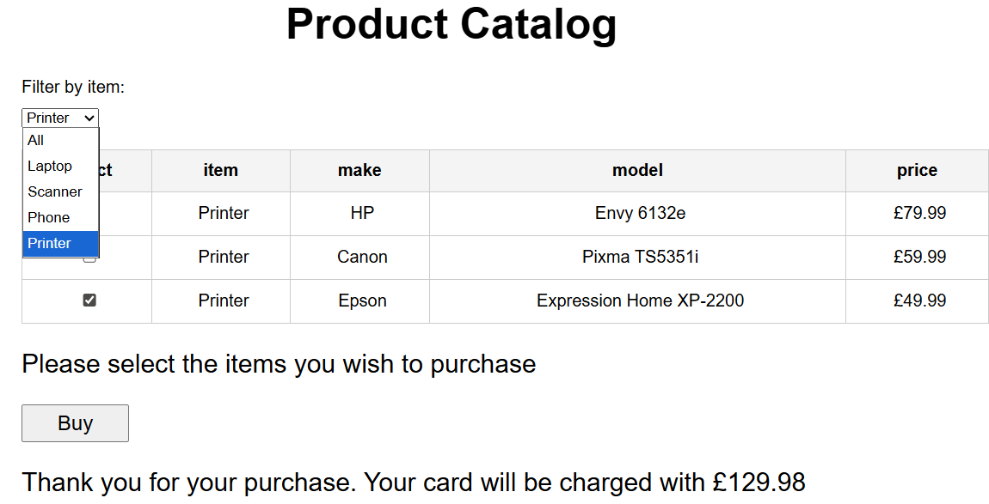

F1 Site
Complete the F1 site. Note there is no need for flexbox for the images, use a grid.

But, prioritise the leaderboard over the images if you are short of time based on the exercise we did today to read the F1 data and write it to the page.

Country flags are optional

If you have any problems, contact me

